Appendix A

Consultation Logs

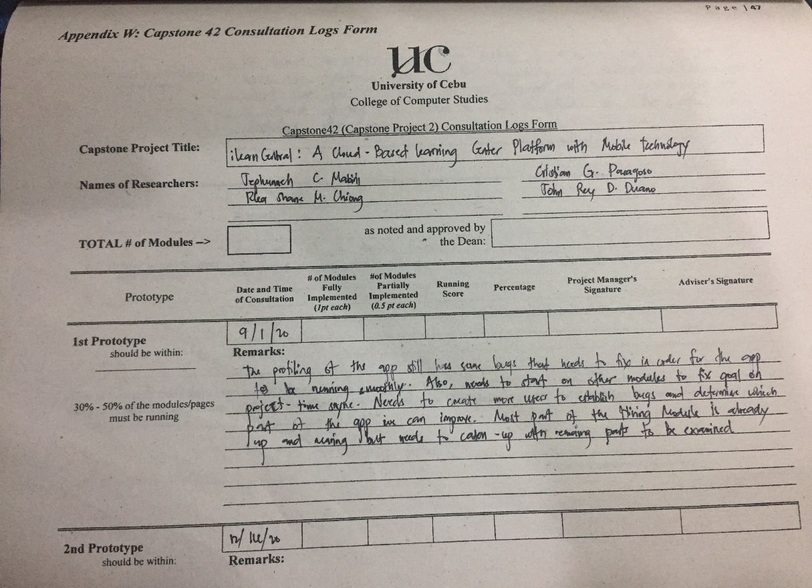

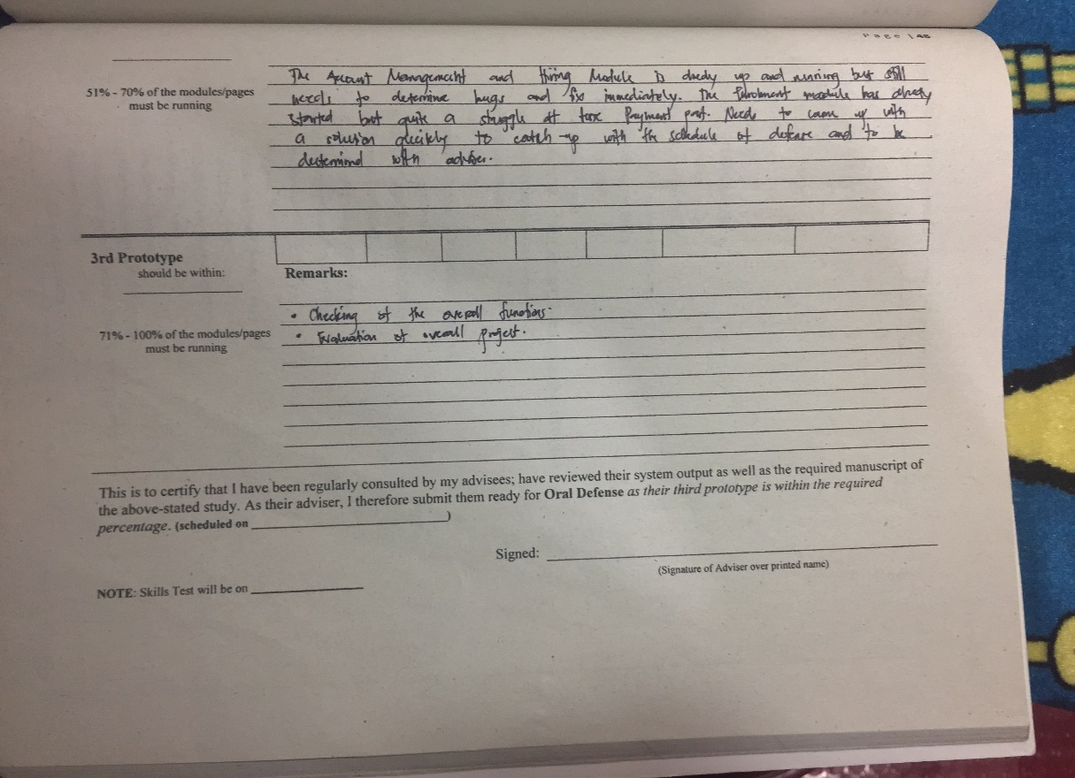

Appendix B

Censor’s Certificate

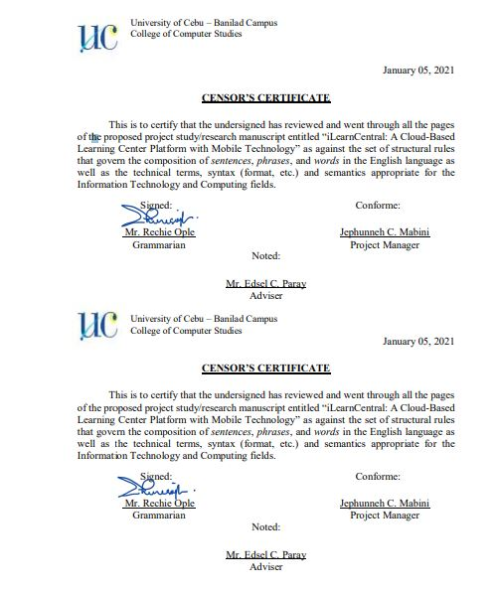

Appendix C

Transmittal Letter (Town Central Adventist Learning Center)

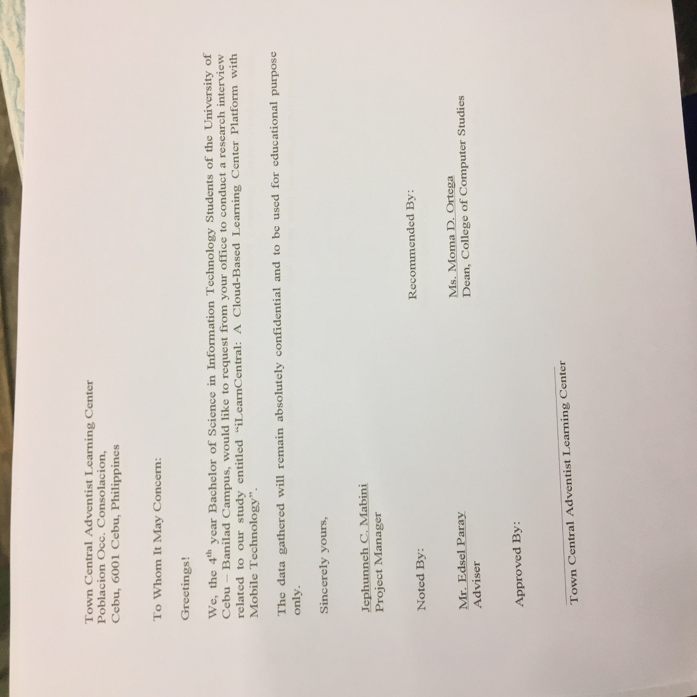

Appendix D

Transmittal Letter (Paraclete Learning Center)

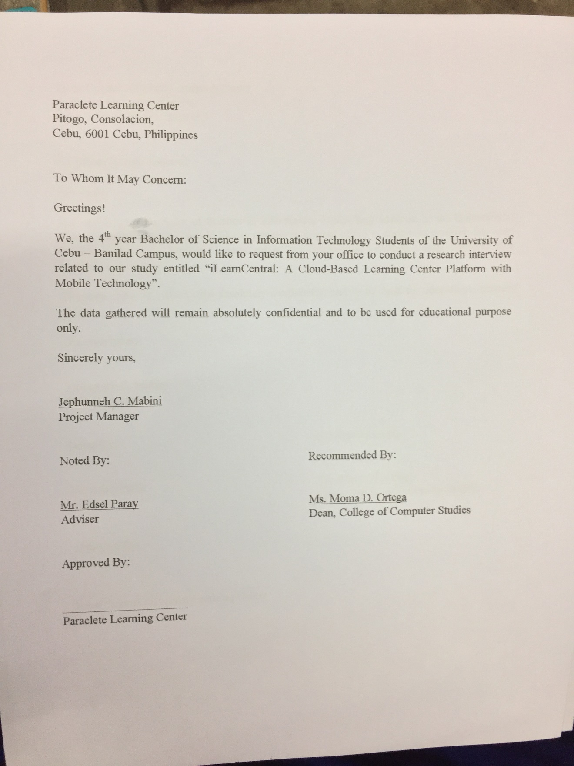

Appendix E

Learning Center Questionnaire

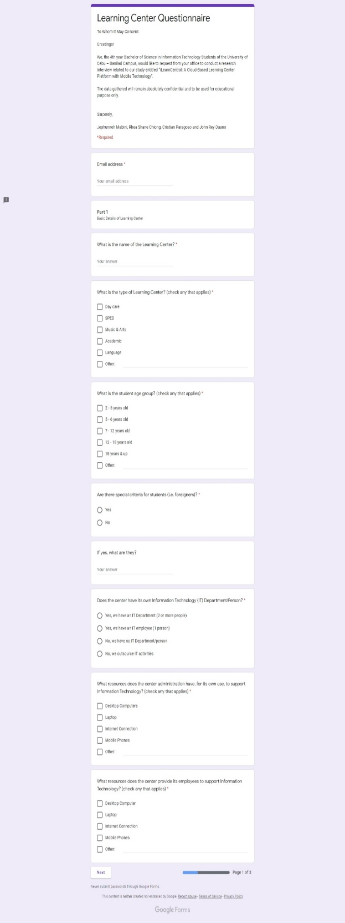 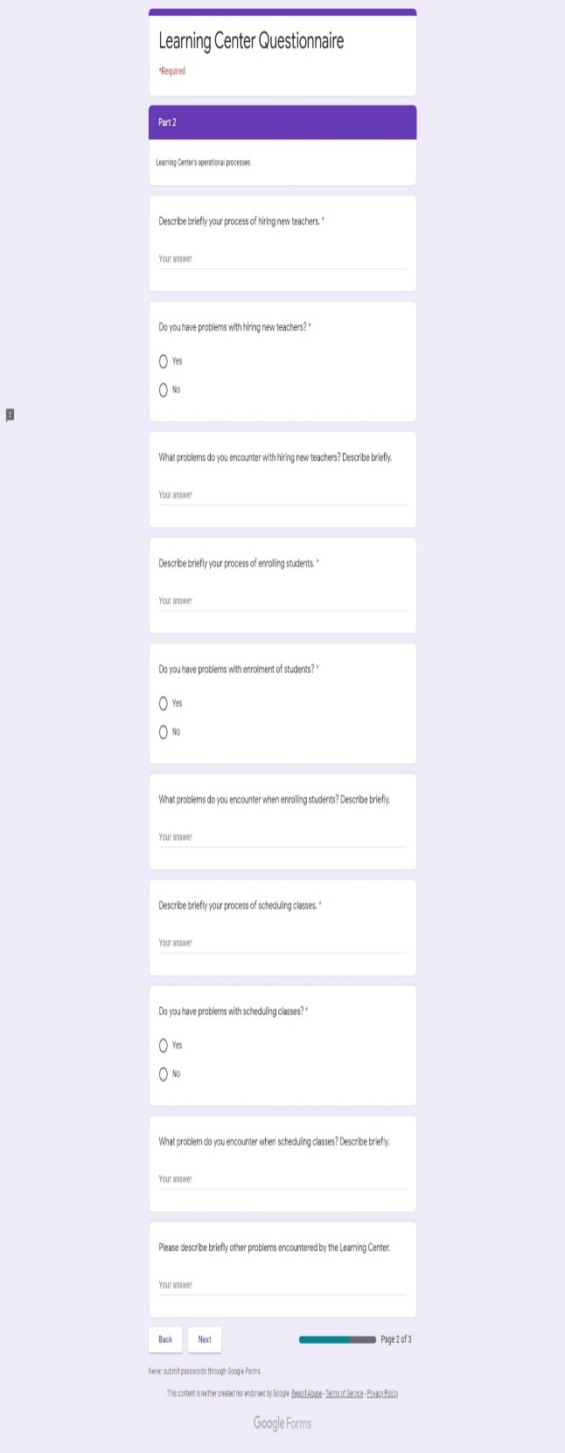

Appendix F

Learning Center Questionnaire Cont’d

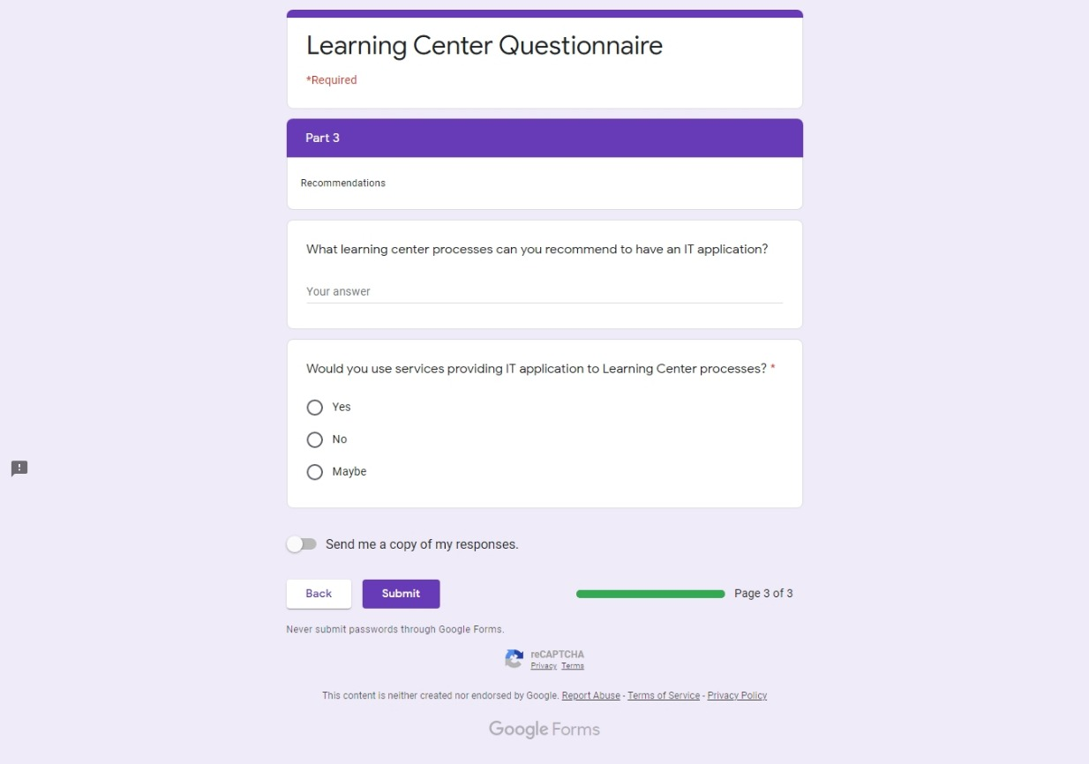

Appendix G

Educator’s Questionnaire

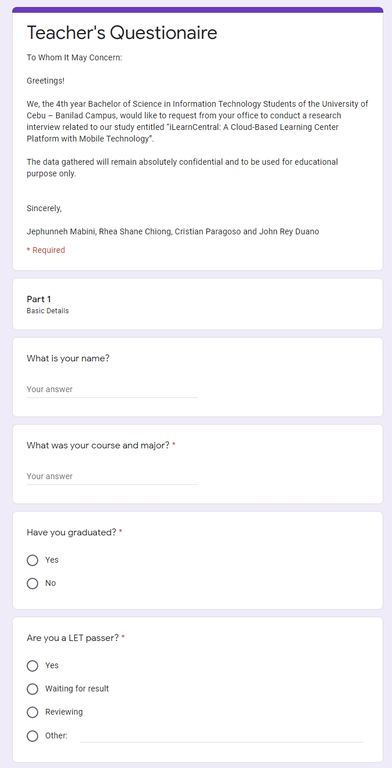 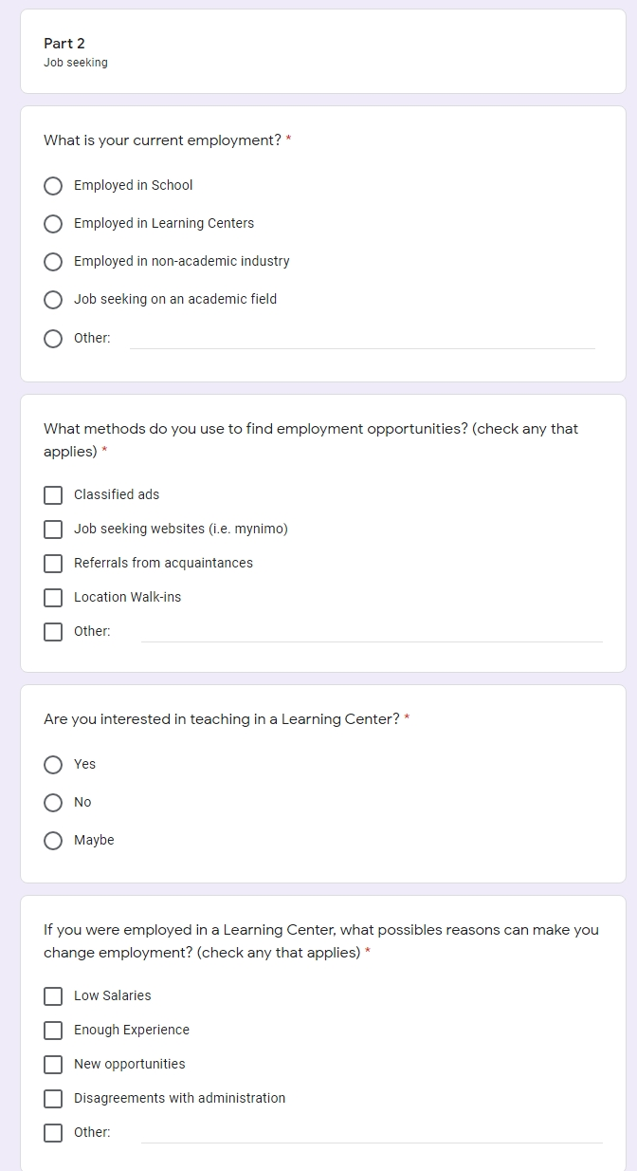

Appendix H

Educator’s Questionnaire Cont’d

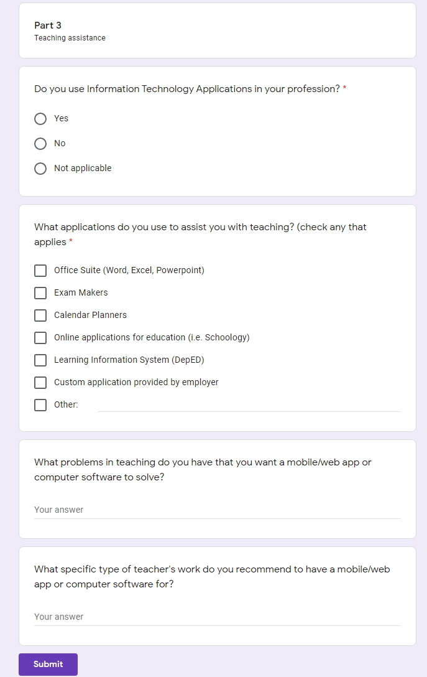

Appendix I

Learning Center Survey Result

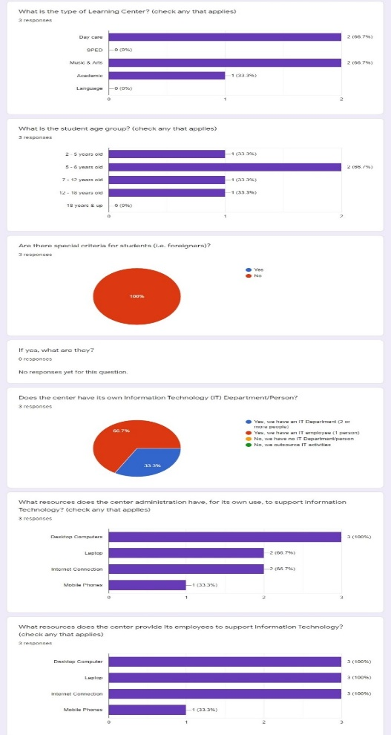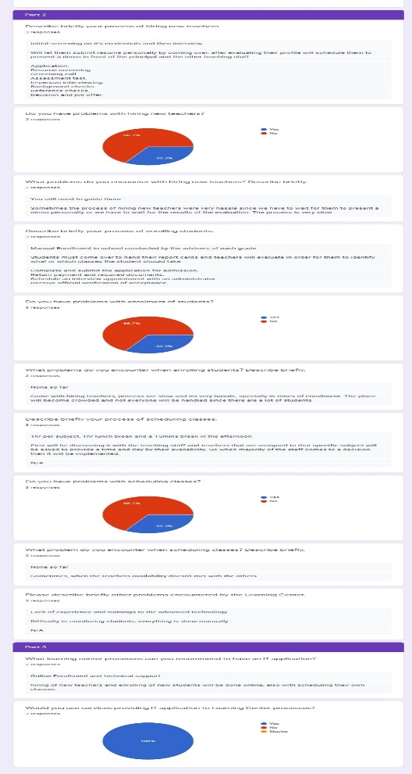

Appendix J

Educator Survey Result

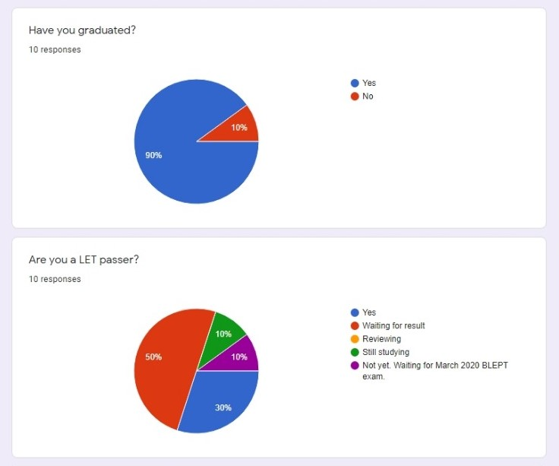  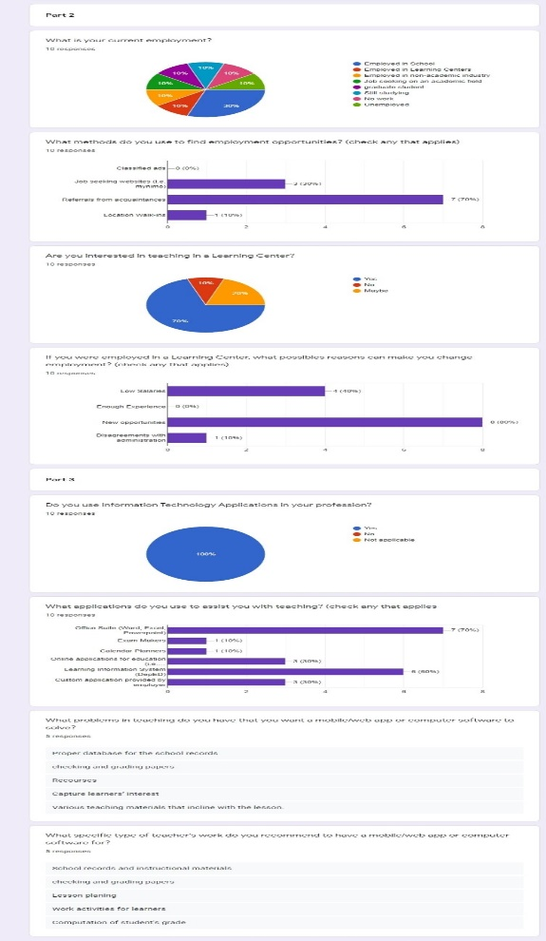

**TEAM PROFILE**

**Jephunneh C. Mabini**

***Project Manager***

The person with authority to manage a Capstone Project from start to finish. Ensures that all the members of the project coordinates well with the team.



**Rhea Shane M. Chiong**

***Software Engineer***

The person who leads the creation of the software project. Manages the design and development of the whole computer software.



**Cristian G. Paragoso**

***Network Designer/ UI Designer***

The person who masters the system’s network design and prepares the UI (User Interface design). Creates the user-design from the user-intended’s point of view.



**John Rey D. Duano**

***QA Tester / Technical Writer***

The person who finalizes the Capstone Project study document, both the system and the Research/ Capstone Project manuscript.

